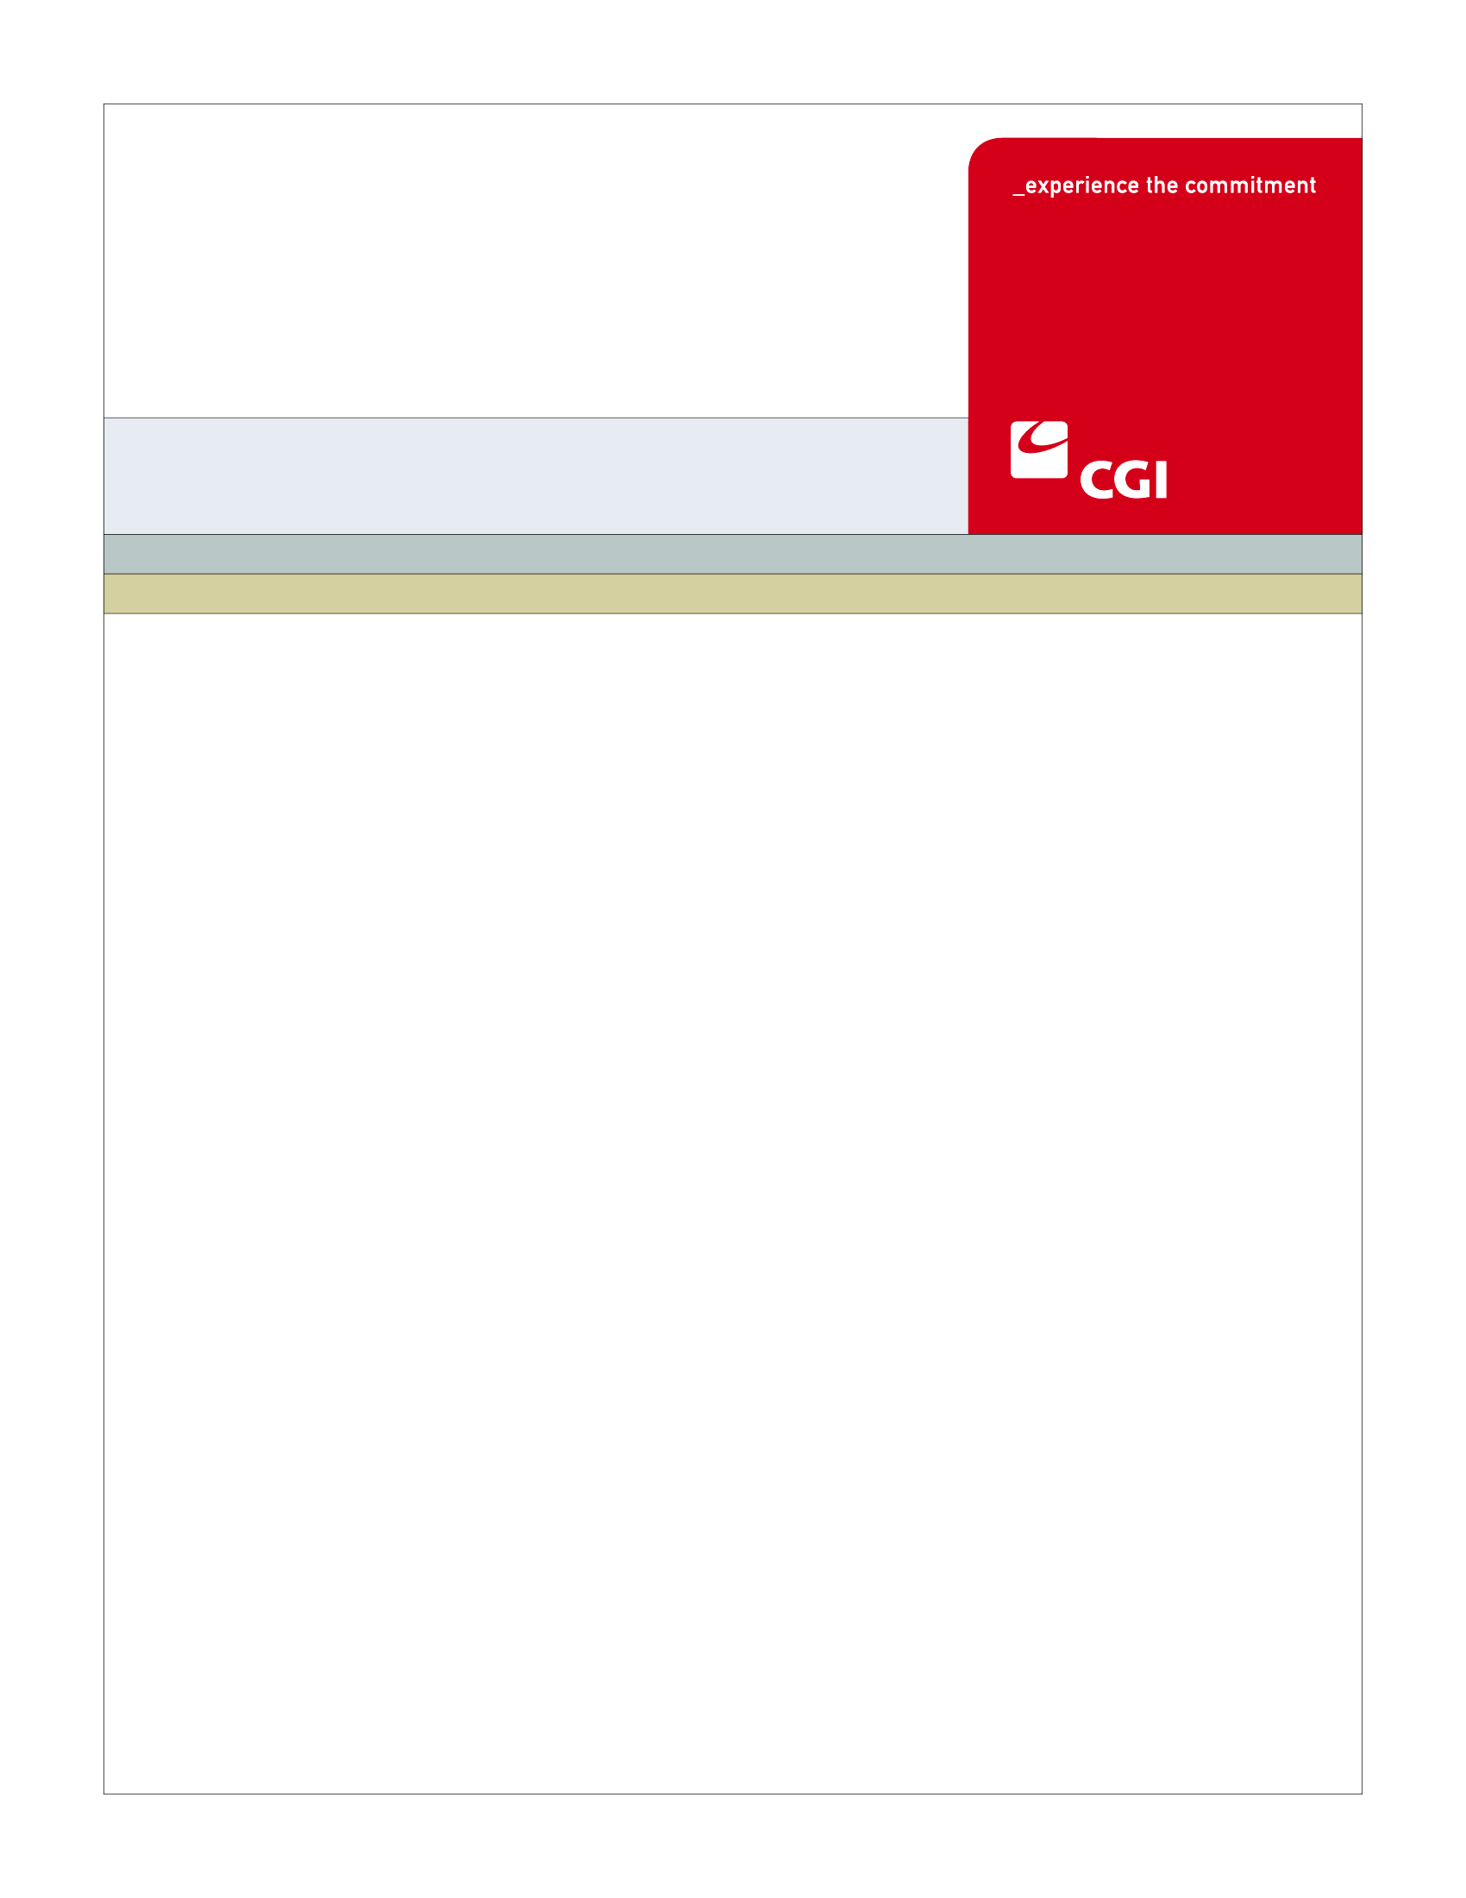SE

**Colorado Health Benefit Exchange (COHBE)**

**Create Individual Account Use Case**

**Version 1.2**

**October 18, 2012**

REVISION HISTORY

|  |  |  |  |
| --- | --- | --- | --- |
| Version | Date | Modified By | Description |
| 0.1 | 08-30-2012 | Diane Dunn, Rob Merry, Kelly Wiley | Initial draft for JAD Discovery Session |
| 0.2 | 9-04-2012 | Rob Merry | Updates from JAD Discovery Session |
| 0.3 | 9-11-2012 | Diane Dunn | Updates from the JAD Elaboration Session |
| 0.4 | 09-19-2012, 09-26-2012 | Rob Merry, Kelly Wiley, Diane Dunn | Updated from first Verification Session, Final Version for Verification JAD Session |
| 1.0 | 10-01-2012 | Rob Merry, Diane Dunn | Verified Use Case, sent for COHBE approval |
| 1.1 | 10-17-2012 | Diane Dunn | Accepted most changes suggested by John Barela |
| 1.2 | 10-18-2012 | Diane Dunn, Rob Merry | Remainder of John’s changes accepted after meeting with COHBE. Verbal sign off received by Rob Merry on 9/18/12. |
|  |  |  |  |
|  |  |  |  |
|  |  |  |  |
|  |  |  |  |
|  |  |  |  |
|  |  |  |  |

TABLE OF CONTENTS

1 Use Case: Create Individual Account 5

1.1 Goal 5

1.2 Brief Description 5

1.3 Requirements Traceability 5

1.4 Primary Actor 6

1.4.1 Individual 6

1.4.2 Employee 6

1.4.3 Broker 6

1.4.4 Navigator 6

1.4.5 Service Representatives 6

1.5 Secondary Actor 6

1.5.1 Exchange 6

1.6 Pre-Conditions 6

1.7 Successful Post-Conditions 7

1.8 Triggers 7

1.9 Assumptions 8

2 Flow of Events 8

2.1 Basic (Main) Flow – Create Individual Account for New User 8

2.1.1 Register to Create an Individual Account 8

2.1.2 Enter Basic Account Information 9

2.1.3 Existing Account for User? 9

2.1.4 Create Account 9

2.1.5 Send Confirmation 9

2.1.6 Next Steps 10

3 Alternate Flows 10

4 Exception Flows 10

4.1 Existing Account Found for User 10

4.1.1 Prompt User to Remember Credentials 10

4.2 User Exits without Creating an Account 10

5 Specifications 10

5.1 Business Rules 10

5.1.1 Basic Account Information Fields 10

5.1.2 Fields populated but not complete 12

5.1.3 Pre-populate email address as Unique Login ID 12

5.1.4 Create COHBE Account Number 12

5.1.5 Determine Notification Method 12

5.2 Process Rules 12

5.2.1 Existing Account for User? 12

5.3 Workflow 13

5.3.1 Process Individual Account Creation 13

5.4 UI Screen Details 14

5.4.1 Individual Register Screen to be customized with Basic Information fields 14

5.5 Communications 15

5.5.1 Imaging Requirements 15

5.5.2 Form Requirements 15

5.5.3 Notices Requirements 15

5.5.4 Other Communication Requirements 16

5.6 Interfaces 16

5.7 Reporting 16

5.7.1 User Experience 16

5.7.2 Business Activities 16

5.7.3 Workflow 16

5.7.4 Community and Public Health 16

5.8 User Security 16

5.8.1 Actor Status Changes 16

5.8.2 Sensitive Data Used in the Use Case 16

5.8.3 Data Transmission Requirements 16

5.9 Activity Log and Audit Trail 17

6 Future Release Notes 17

7 Appendix A - Glossary 17

# Use Case: Create Individual Account

## Goal

The goal of this Use Case is to successfully create an individual account to log into the Exchange for enrollment.

This Use Case completes succesfully when the account is created and individual has a unique user ID and password to log into the Exchange.

## Brief Description

An individual's account must be established to allow access to apply for coverage through hCentive on the Individual Exchange. Employees will establish an individual account on the Individual Exchange for their shopping of employer sponsored plans or to apply for individually offered plans. Authorized users may also create accounts on behalf of individuals and employees. After the Consumer accesses the register screen, basic information is entered to create an account. When submitted, the system is checked to see if an account for the Consumer already exists in the Exchange system. If not, the account is created. If so, the Consumer is asked if they need help to proceed.

## Requirements Traceability

The following requirements are covered within this Use Case:

* GF010: There shall be two distinct URLs for customers to access the Exchange: an Individual URL (for individual households) and a SHOP URL for small employers.
* IN010: The System shall have a separate entry point and portal for Individuals conducting business on-line with the Exchange (Individual Portal).
* GF076: Service Representatives will be able to perform all of the activities of the System on behalf of Customers should Customers need assistance or not have access to the System. Activities of Service Representatives will be limited to the functions required by their roles.
* EL031: The System shall support a self-service eligibility process where a non-applicant can apply for benefits on behalf of others without the non-applicant having to provide his/her social security numbers.
* EL100: The System shall require the customer to create an account prior to eligibility determination and enrollment in a health plan.
* AM170:The System shall capture and store required information required to establish an account include personal information, username and password with the username and password schemas to be determined by COHBE.
* AM085: The System shall include a login for SHOP employees that will be the same as the Individual login. SHOP employees and Individuals will use the same URL (and login) for managing their account.
* IN030: Individual Exchange customers shall have a unique login and password.

## Primary Actor

### Individual

An individual will enter the Exchange to create an individual account.

### Employee

An employee will enter the Exchange to create an individual account.

### Broker

Brokers logging into their broker account will have the ability to create an individual account on behalf of their customer.

### Navigator

Removed for separate tracking

### Service Representatives

Removed for separate tracking

## Secondary Actor

### Exchange

The Exchange will track and store account information for users of the Exchange.

## Pre-Conditions

* User/Consumer selects Individual Portal.
* Brokers and licensed Service Representatives must be signed into their Broker or Representative account.
* Back Office staff or Service Representatives, with appropriate authority, creates an account on behalf of an individual.
* Data from prescreening (Use Case ELG-001 Prescreen for Eligibility) and data gained from the email from an employer (SH-003 Manage Employee Roster Use Case) are available to Create Individual Account.
* Data passed from Pre-screening and email link are:

| Data Element |
| --- |
| Zip Code |
| First Name |
| Email |
| Birth Date |

## Successful Post-Conditions

* An active account is created for the Individual with a COHBE Account Number and associated unique ID and password stored in the system.
* Notification will be sent to the individual informing them an account has been created.
* The individual is actively logged into the Exchange
* Data created from Create Individual Account:

| Data Element |
| --- |
| Name (First, Middle, Last) |
| Date of Birth |
| Log In/ Password |
| Preferred Language |
| Contact Preference (Email or Mailing Address) |
| Email |
| Mailing Address |
| Security Question/Answers 1, 2, and 3) |

## Triggers

The following events may trigger this Use Case:

* A consumer decides to create an individual account and has clicked “Create an Account”
* A consumer receives an email from their employer inviting them to participate in the Exchange and has clicked the link in the email
* A Broker enters through the Broker Portal and clicked the action needed to create an individual account for their client.

## Assumptions

* Currently, the hCentive application will only accommodate a single account/login per household. A Future Release item will address the ability to have multiple account/login per household.
* Navigator functionality will be tracked in separate navigator-specific use cases.

# Flow of Events

The Business Process Activity diagram below shows the COHBE processes for the Create Individual Account Use Case. The steps numbered on the diagram below have detailed explanations in the sections that follow.

## Basic (Main) Flow – Create Individual Account for New User

### Register to Create an Individual Account

* Consumers can access the Create Individual Account by:
  + Clicking the “Register” link at the top of the page
  + Clicking the “Create an Account” on the My Account/Sign On screen
  + Clicking the Enroll while anonymous shopping, then on “Create an Account” on the My Account/Sign On screen
  + Clicking the link from email inviting employee to create an account
* Brokers can only access the Create Individual Account by:
  + Entering through the Broker Portal, logging into their broker account, and clicking on “Create an Account” for an individual.
* The employer is added automatically to the employee’s account if accessing from the employer invitation email. If the employee is creating an account from the Exchange, the Employee will need to know the Employer Code to be linked manually.

### Enter Basic Account Information

* The user will enter the Basic Account Information.
* Specific fields entered on the basic information are documented in Business Rules, Section 5.1.1.
* After fields are populated, the user clicks the Create button.
* Fields are edited for completeness and validity. If errors exist, the user is prompted to correct them before proceeding (Business Rules, Sections 5.1.1, 5.1.2)
* Non-Individual actors will not enter the password and security questions. These items will be defaulted and the Individual will be required to fill them out when first logging in.

### Existing Account for User?

The Exchange system will have the ability to check if an existing account is in the system (Process Rules, Section 5.2.1). In the basic flow, if an existing user is not found, the system will proceed to the next Step 2.1.4, Create Account. If there is an existing account, the exception flow is entered at Step 4.1.1, Prompt User for Login Credentials.

### Create Account

The basic information entered will be used to create an account in the Exchange. A record will be saved to the database and a unique account number will be associated to the individual account record. After the account is created, go to Step 2.1.5, Send Confirmation.

### Send Confirmation

A confirmation is sent to the individual after the account is created. The method for the confirmation notification (Section 5.5.3, Notices Requirements) is based on the contact preferences selected (Business Rules, Section 5.1.3) in Basic Information.

While either contact preference may be selected, design decisions will be based on driving the individual towards using email as the contact preference.

### Next Steps

Once the account is created, the user/consumer may proceed to any number of places on the website, including (but not limited to):

* Enrollment
* Plan selection
* My Account, password and security
* My Account, other tabs
* Prescreen for eligibility
* Exiting the website

# Alternate Flows

There are no alternate flows for Create Individual Account.

# Exception Flows

## Existing Account Found for User

### Prompt User to Remember Credentials

If an existing account (Basic Course, Step 2.1.3) is found to exist in the Exchange, an error will be returned saying the account exists. The AM-001 Create Individual Account Use Case ends and AM-007 Manage Password Use Case begins.

## User Exits without Creating an Account

A user may exit the Create Individual Account process by choice at any time. If that happens, the user must restart the process to create an individual account.

# Specifications

## Business Rules

### Basic Account Information Fields

The user enters data for Step 2.1.2. All fields must be complete using the expected data type and format to check for an existing account.

* First Name (Required, may be pre-populated from anonymous shopping or shopping cart details)
* Middle Name (Optional)
* Last Name (Required)
* Date of Birth (Required in MM/DD/CCYY format and is a valid date, may be pre-populated from anonymous shopping or shopping cart details)
* Password (Required for Individuals not shown for other actors, See Section 5.8.1 Password Security Properties)
* Retype Password (Required for Individuals not shown for other actors)
* Preferred Language (Required)
* Contact Preference (Required Email or Mailing Address)
* Contact Details (Email and/or Mailing Address)
  + Email address ([name@domain.extension](mailto:name@domain.extension); Conditionally required based on selection of contact preference)
  + Mailing Street Address (Conditionally required based on selection of contact details; combination of letters and numbers, longer than one character)
  + Mailing City (Conditionally required based on selection of contact details; Letters no numeric characters)
  + Mailing Zip (Conditionally required based on selection of contact details; Numeric 5 or 9 digits)
  + Mailing State (Conditionally required based on selection of contact details; populated based on zip code entered)
  + County (Conditionally required based on selection of contact details; populated based on zip code entered
* Login ID (Required; user entered field and unique to the system, default to email address as it is typed in)
* Security Question 1 (Required for Individuals not shown for other actors)
* Security Answer 1 (Required for Individuals not shown for other actors; enter answer using alpha-numeric characters)
* Security Question 2 (Required for Individuals not shown for other actors; previous question is not displayed in drop down)
* Security Answer 2 (Required for Individuals not shown for other actors; enter answer using alpha-numeric characters)
* Security Question 3 (Required for Individuals not shown for other actors; previous 2 questions are not displayed in drop down)
* Security Answer 3 (Required for Individuals not shown for other actors; enter answer using alpha-numeric characters)
* Attestation: Check boxes on the screen to provide attestations – at least one of the following attestations must be checked (along with the agreement for the Terms of Service) before proceeding:
  + I am a registered Broker, Navigator, or Service Representative and have the authority to act for this individual.
  + I am the primary user/account holder.

### Fields populated but not complete

If fields are populated but not complete, errors will be generated regardless of which option has been selected for contact preferences. The following edits will be in place and will not allow the user to submit:

* Email Address is not in the correct format ([name@domain.extension](mailto:name@domain.extension))
* Mailing Street Address is populated without City or Zip Code
* Mailing City is populated without Street Address or Zip code
* Mailing Zip Code is populated without Street Address or City

### Pre-populate email address as Unique Login ID

If user enters an email address, the system will pre-populate email address as the unique login ID. The Unique Login ID will be editable and allow the individual to edit the field.

### Create COHBE Account Number

Upon successful submission, a COHBE Account Number will be generated as an identifier to be used by the Individual. The COHBE Account Number will be included on any documentation the individual receives, either by email or letter and displayed on my profile after the individual logs into the Exchange.

### Determine Notification Method

Contact preference will determine the method for notifying the user that an account has been created.

## Process Rules

### Existing Account for User?

Step 2.1.3 will check for an existing account associated with the user based on the basic information fields. A verification will be performed to check:

* An existing Unique Login ID
* An exact match between, Date of Birth, First Name, Middle Name, Last Name and contact details (email and/or address)

If there is a match, an error is given to the user (Forgot Log In? Forgot Password?) and the AM-007 Manage Password (and Log In) Use Case is then followed.

## Workflow

System workflow will be used by back office staff to process new individual applications that are mailed or faxed. Authorized staff members assigned to create accounts for individuals will access their system queue to process applications. The section below provides additional information about the workflow process for paper applications.

### Process Individual Account Creation

* Task Name: Process Individual Account Creation Paper Application
* Worklist Name: Create Individual Acccount from Mail/Fax Application
* Task Type: Back Office Staff Worklist
* Sort Criteria: First in, first out
* SLA Watch: TBD based on date/time stamp application is received
* SLA Warning: TBD based on date/time stamp application is received
* Escalation: Send email to Back Office staff supervisor
* Escalation Worklist: Create Individual Account from Mail Application Escalation Worklist
* Task Actions:
  + - Review Mail Application for completeness
    - Validate user account does not already exist in the Exchange
    - Scan application document
    - Scanned Applications become work items to be processed by Back Office Staff
    - Back Office Staff with the appropriate security role creates individual accounts for the items in their worklist
    - Generate welcome letter that includes the COHBE Account Number, log in ID and request a call to the Service Center for the account to be unblocked
    - See Section 5.5.4 Other Communication Requirements for the Service Representative tasks
    - Continue to next task in the work queue

## UI Screen Details

### Individual Register Screen to be customized with Basic Information fields

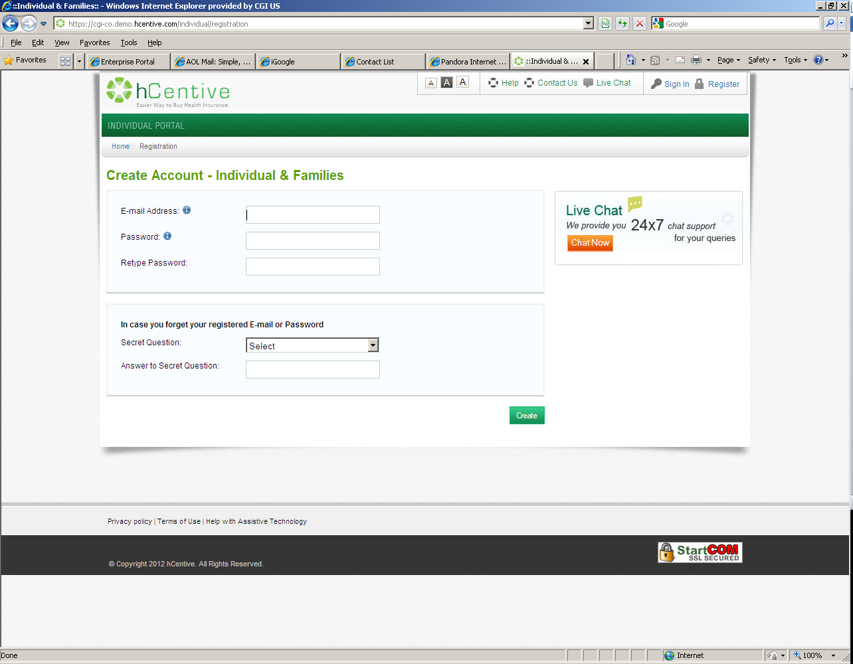

Fields to be added to this screen with required fields denoted by a red asterisk are:

* First Name
* Middle Name
* Last Name
* Date of Birth
* Preferred Language
* Contact Preference
* Contact Details
  + Email Address
  + Mailing Street Address
  + Mailing City
  + Mailing Zip Code
  + Mailing State (default to auto-populated value)
  + Mailing County (default to auto-populated value)
* Login ID
* Security Question 2
* Security Answer 2
* Security Question 3
* Security Answer 3
* Attestation Checkboxes:
  + I am a registered Broker, Navigator, or Service Representative and have the authority to act for this individual.
  + I am the primary user/account holder.

## Communications

### Imaging Requirements

* Mail Applications will be imaged.
* A mail application will be used to create the account for the user.

### Form Requirements

* Application forms can be downloaded to manually enter the information needed to create an individual account.
* Application forms will be addressed in the Process Offline Correspondence Use Case.

### Notices Requirements

* Individuals who select email as their contact preference will receive an email confirmation generated by the system which will include the COHBE Account Number and login ID. The password will not be sent as part of the email.
* Individuals who select mailing address as their contact preference will receive a confirmation letter in the mail which will include the COHBE Account Number and login ID. The password will not be sent as part of the letter.
* For mail applications, a process will be in place to have a letter generated to the mailing address. See Section 5.5.4 Other Communication Requirements.

### Other Communication Requirements

If a letter is generated from the Back Office based on a mailed application for an account, the letter will include the COHBE Account Number, the log in ID and request a call to the Service Center for the account to be unblocked.

* When Service Center receives the call, allow Service Representatives to search for the account and to set a temporary password for the individual.
* When Individual logs in for the first time, they will be forced to reset their password and to set their Security Questions and Answers.

## Interfaces

There are no interfaces for the Create Individual Account Use Case.

## Reporting

### User Experience

* Account creation source (electronic, paper)Number of accounts from anonymous shopping
* Number of accounts that use prescreen

### Business Activities

* Number of accounts created
* Number of accounts with Email as preference
* Number of accounts with Mail Address as preference

### Workflow

* Accounts created by Broker/Service RepNumber of letters generated by creating individual accounts

### Community and Public Health

## User Security

### Actor Status Changes

An Individual account is created and has active status

### Sensitive Data Used in the Use Case

No sensitive data is used in this use case.

### Data Transmission Requirements

There are no data transmission requirements for the Create Individual Account Use Case.

## Activity Log and Audit Trail

No updates captured at this time.

# Future Release Notes

There is a potential Future Release Note associated with Parking Lot item 222: Currently, hCentive only allows for one log in ID per household.  The concern is that, as family composition changes, there may be household members associated with other primary users or members which become their own households (for example, adult children).  The request is for hCentive to allow for one to many (account to family members), one to one (person to account) and many to many (family members to accounts) log in IDs.

# Appendix A - Glossary

| Term | Definition |
| --- | --- |
| COHBE | Colorado Health Benefit Exchange, or the Exchange |
| Back Office | CGI provides administrative and support services related to processes that cannot be completed by the system. |
| CMS | Centers for Medicare and Medicaid Services |